**PowerTeacher Pro Report Card Directions**

|  |  |
| --- | --- |
| mage result for powerteacher pro | 1. Log into your Power Teacher Unified classrooms account where you take attendance. |
|  | 1. Click on the tab that says grading. |
|  | 1. Click on the tab that says grades. |
| Q1 | 1. Go to the top where it says quarter 1. Press on the blue arrow to see other options and select standards. |
|  | 1. (Now you should see your class roster on the side and across you will see the codes for the categories that are being assessed. )Click on the box where you are going to enter the grade and you will be able to see what you are assessing. |
|  | 1. After you have finished typing in the grades for that subject area click save. |
|  | 1. On the top of the page you will find a drop down menu with the subject areas. Select each subject area separately to type in the grades in that area. (Remember to save your grades in every area- K) |
|  | 1. The comments are located in the homeroom area. Navigate to the homeroom tab and find the comments. Click on the chat box and add a comment from the comment bank. |

**Tips:**

-When you click on the box to type in the grade, under the numbers there are arrows showing auto fill options for up and down and side to side.

-In the ELA area, the first 4 areas require an exact number/not a rubric score. (uppercase letters, lowercase letters, sounds, sight words) (K)

-The report card fits 2 comments for each student. Any more will be cut off. Select your comments and put the comments in English and Spanish. If you know the child/family is English dominant you can just put the comments in English.

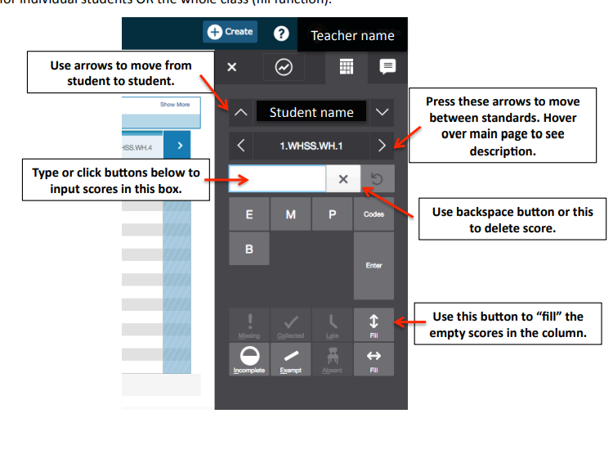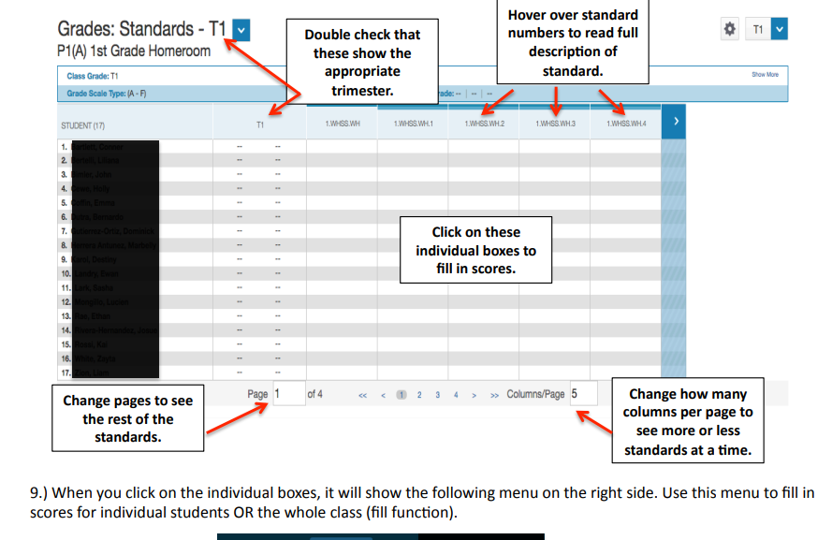

Q1

Q1